**Installation Instructions for setting DevKit for Ruby in Windows**

While installation is (in general) simple, please ensure you carefully follow each step below.

**1. Download Files**

1. The current DevKit is available at the <http://rubyinstaller.org/downloads>. Download DevKit-mingw64-32-4.7.2-20130224-1151-sfx.exe under “For use with Ruby 2.0 (32bits version only):” as we use only 32-bit ruby.
2. You should have installed ruby 2 under “C:/Ruby200” only.

**2. Extract Files**

1. Create a folder “devkit” under “C:\Ruby200”
2. Run the downloaded exe file and give the location as “C:\Ruby200\devkit” and then click Ok button.

**3. Run Installation Scripts**

* 1. Open the command prompt
  2. Type “cd devkit”
  3. Type “ruby dk.rb init” to generate the config.yml file to be used later in this Step. Your installed Rubies will be listed there (only those installed by a RubyInstaller package are detected at present).
  4. edit the generated config.yml file and add “- C:/Ruby200” after the last --- (triple hyphen) , save and close the file.
  5. Type “ruby dk.rb review” to review the list of Rubies to be enhanced to use the DevKit and verify the changes you made to it are correct. It should show the “C:/Ruby200” or else there is some error in setup.
  6. Finally, type “ruby dk.rb install” to DevKit enhance your installed Rubies. This step installs (or updates) an operating_system.rb file into the relevant directory needed to implement a RubyGems pre_install hook and a devkit.rb helper library file into<RUBY_INSTALL_DIR>\lib\ruby\site_ruby. NOTE: you may need to use the --force option to update (with backup of the originals) the above mentioned files .

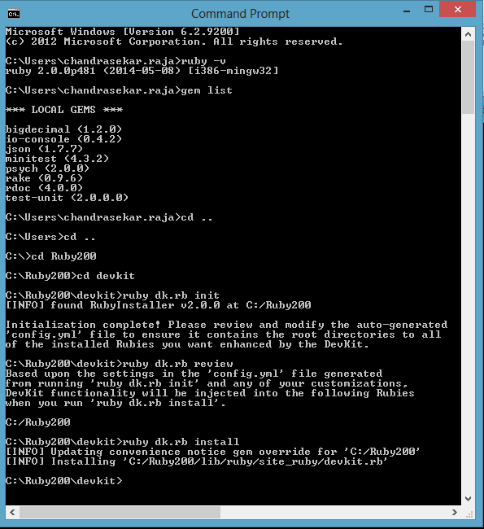

* 1. If you use the x64 version of ruby you might get an error saying `Invalid configuration. Please fix ‘config.yml’ and rerun ‘ruby dk.rb install’`. See <http://stackoverflow.com/questions/16523607/cant-get-ruby-devkit-configuration-file-autogenerated-properly>.

**4. Test Installation**

* 1. Confirm your Ruby environment is correctly using the DevKit by running “gem install json --platform=ruby” in the command prompt. JSON should install correctly and you should see with native extensions in the screen messages.
  2. Next run ruby -rubygems -e "require 'json'; puts JSON.load('[42]').inspect" to confirm that the json gem is working.